MONUMENT’AFRICA — AGAINST PERMANENCE
Contemporary African Art, Heritage and Monumentality at the Scale of a Village
The Margaux and Raphaël Blavy Collection, marking the 50th anniversary of Alexander Calder’s death

PRESS RELEASE
Autumn 2026

On the occasion of the fiftieth anniversary of Alexander Calder’s death, the Margaux and Raphaël Blavy Collection and the AR(t)CHIPEL Festival, in partnership with the Centre Pompidou and the Centre-Val de Loire Region, present MONUMENT’AFRICA — Against Permanence, a major cultural initiative bringing contemporary African art to the Château de Montgoger and the village of Saint-Épain.
Bringing together around twenty international artists—among the most important voices in contemporary African and Afro-descendant art—MONUMENT’AFRICA unfolds across the stables of Château de Montgoger, the village church, the wooden theatre and the Presbytery Museum, creating a journey in which heritage, architecture, landscape and contemporary creation enter into dialogue through monumental works, immersive installations and interventions conceived specifically for each site.
Yet MONUMENT’AFRICA is more than an exhibition.
The project forms part of a broader ambition: to establish Touraine as a new territory for contemporary creation, where art becomes a catalyst for cultural activation, international dialogue and the reinvention of heritage.
Against the exceptional backdrop of the Calder Year—with heightened institutional, cultural and media attention surrounding his legacy in Touraine—MONUMENT’AFRICA aims to be one of the highlights of the 2026 regional cultural season.
Led by the Margaux and Raphaël Blavy Collection—now recognised as one of the French collections actively engaged with contemporary African and Afro-descendant art—the project continues a line of inquiry initiated through the exhibitions Africains Everywhere (2024) and NOIR MATTERS (2025), this time presenting an experience of unprecedented scope in which the exhibition becomes a territory.
At the intersection of Loire Valley heritage, Calder’s legacy and contemporary African creation, MONUMENT’AFRICA is grounded in a simple conviction: the places most deeply rooted in history are sometimes those that allow us to think most freely about the present and the future, and artists have the power to help us understand the world differently.

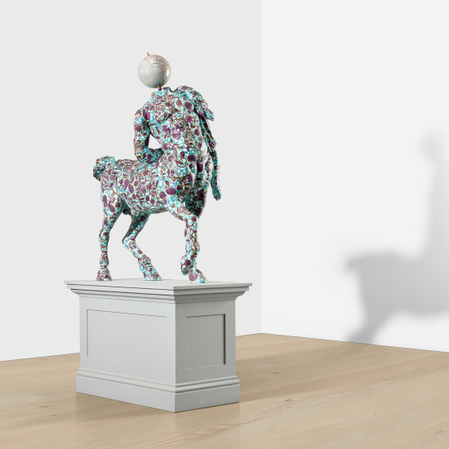
Yinka Shonibare CBE RA, The Furietti Old Centaur (2018)

MONUMENT’AFRICA — AGAINST PERMANENCE
The monument has long been associated with the idea of permanence.
It embodied authority, official memory, power and stability.
In many African countries, the decades following independence saw the emergence of new monumental forms intended to embody national narratives and collective aspirations.
Today, a new generation of artists takes up these inherited forms and displaces them.
The monument is no longer the expression of an official truth.
It becomes a space of negotiation between memory and forgetting, presence and disappearance, inheritance and invention.
MONUMENT’AFRICA brings together some of the most compelling approaches to this transformation.
The monument ceases to be a statement.
It becomes a question.
Suspended, fragmented, diverted, displaced or transformed, it ceases to be an architecture of power and becomes an architecture of relation.

CALDER AND THE END OF THE MONUMENT
Alexander Calder profoundly transformed the way we think about sculpture.
With his mobiles, he liberated form from its weight.
With his stabiles, he challenged the boundary between stability and movement.
His work marks the transition from sculpture conceived as a permanent presence to sculpture conceived as a system of relationships.
MONUMENT’AFRICA extends this intuition.
The artists brought together in the exhibition do not seek to create new monuments.
Instead, they question what remains of the monument when certainties begin to waver.
Their works suspend, displace, fragment or transform forms inherited from power.
The monument ceases to be an architecture of domination.
It becomes a space of circulation, memory and transformation.

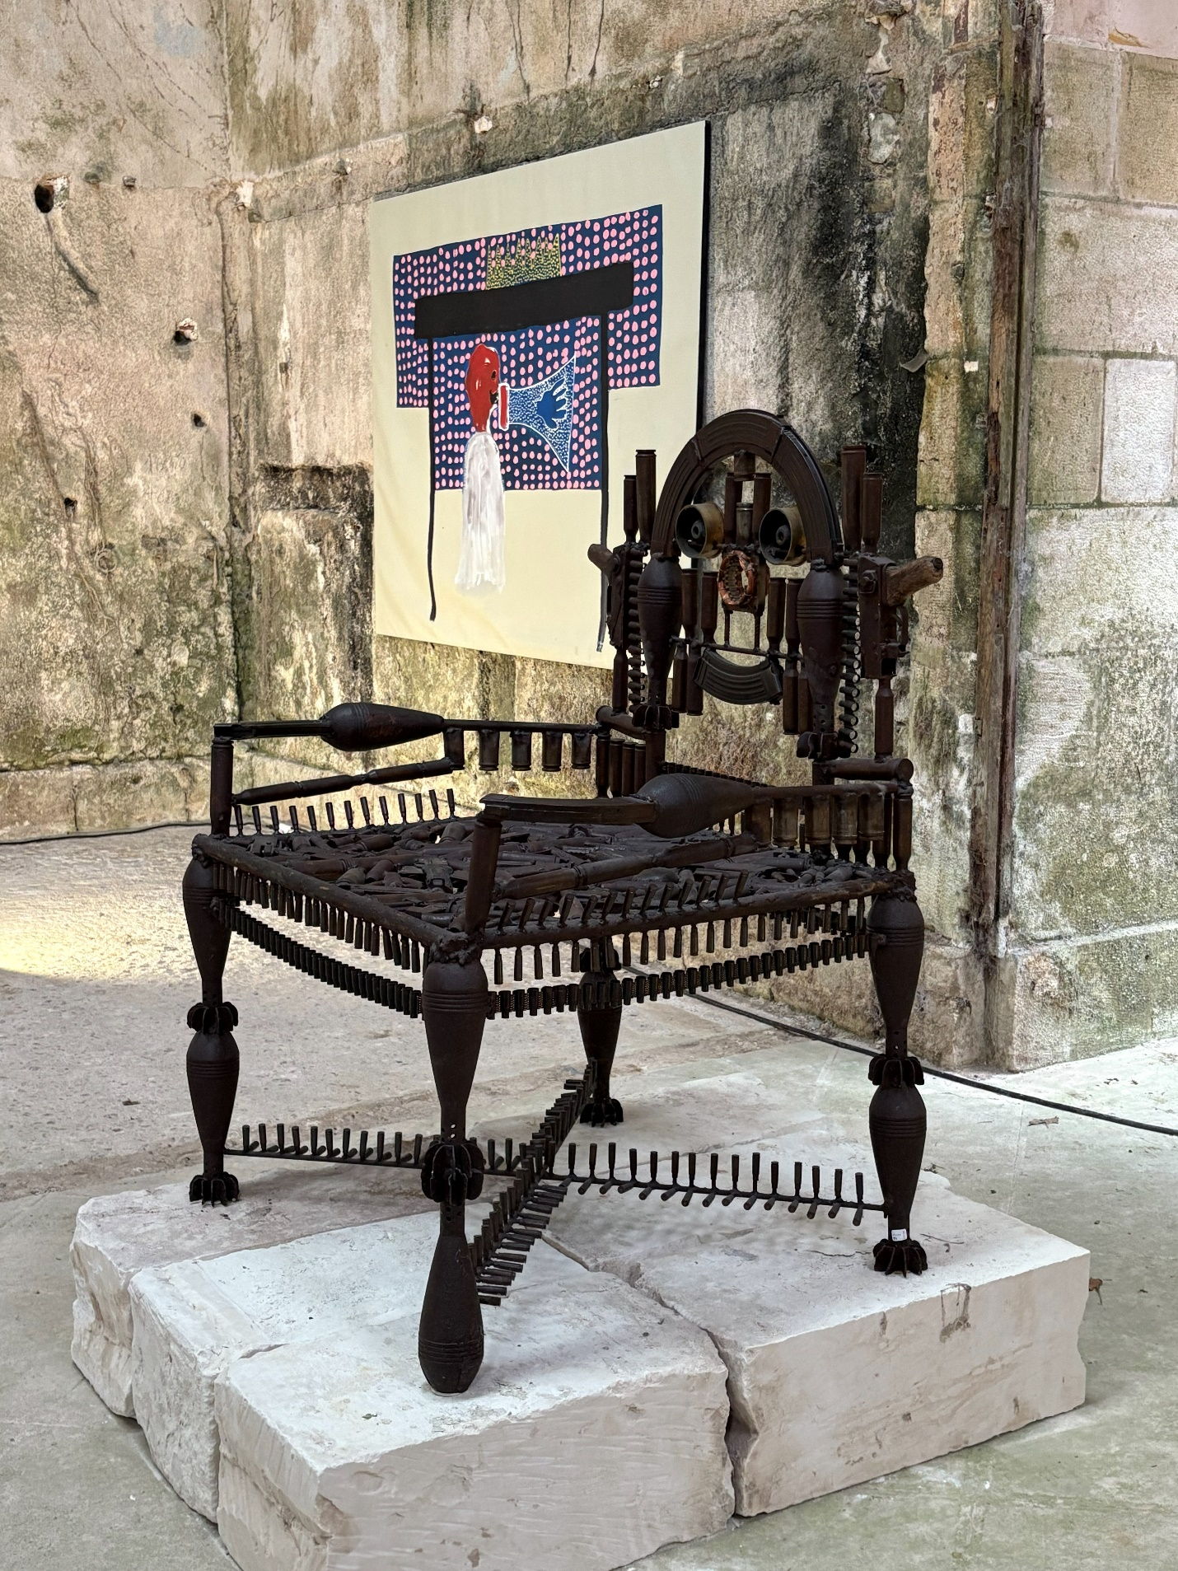
Gonçalo Mabunda, The Throne of the Emperor of Gaza (2018), Decommissioned weapons

A REGIONAL AMBITION

MONUMENT’AFRICA is guided by a simple commitment: that major artistic experiences should not be reserved for metropolitan centres. At a time when contemporary creation appears concentrated in a handful of international hubs, it is necessary to imagine other cultural geographies capable of bringing heritage, place and artistic creation into dialogue on a more human scale.
Touraine offers exceptional assets for this.
Rich in heritage, landscapes and artistic experimentation, it was also a chosen home for Alexander Calder and Max Ernst. Yet this history remains largely underused in its potential to generate new projects.

MONUMENT’AFRICA seeks to activate this legacy rather than merely commemorate it.
The exhibition thus becomes the starting point for a broader reflection on how contemporary art can reinvest places, create new forms of circulation and renew our relationship with heritage.
The project follows in the footsteps of Africains Everywhere and NOIR MATTERS, two exhibitions that have gradually established Château de Montgoger as a place of dialogue between heritage and contemporary creation.

With MONUMENT’AFRICA, this ambition enters a new phase.
The village itself becomes the exhibition space.
Touraine holds a singular place in the history of modern art. A few kilometres from Saint-Épain, Alexander Calder established his studio in Saché and developed some of his most important work there. Max Ernst likewise found in the region a place of freedom and experimentation.
This geographical proximity is not simply a historical coincidence.
It reminds us that major artistic adventures can emerge far from traditional centres of power.
Today, the region’s landscapes, vernacular architecture, châteaux, villages and rural spaces continue to offer a privileged setting in which to imagine new relationships between heritage and creation.
MONUMENT’AFRICA belongs to this history while giving it contemporary resonance.
This is not about celebrating Calder.
It is about pursuing some of the questions he opened.
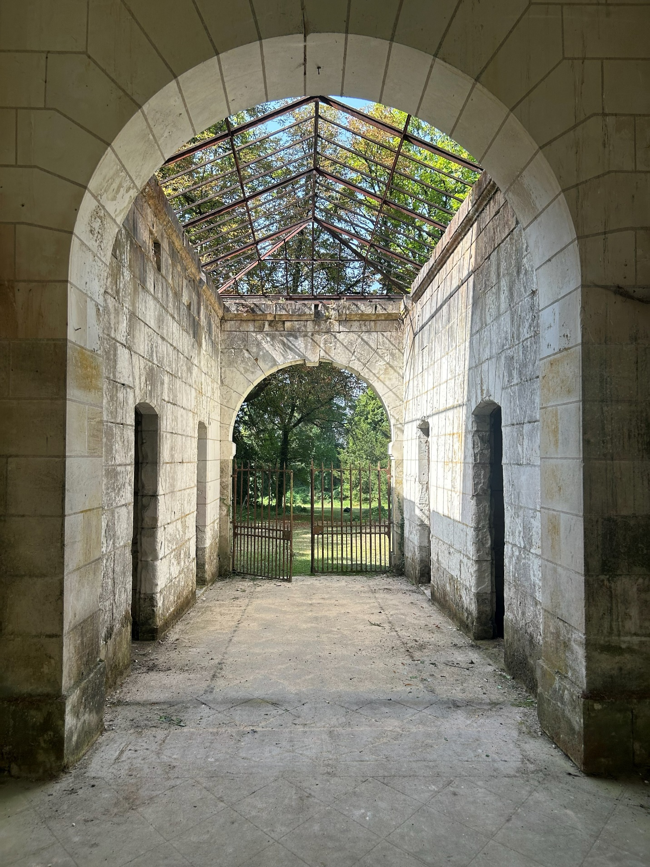

AN EXHIBITION AT THE SCALE OF A VILLAGE
MONUMENT’AFRICA unfolds across four sites that together form an immersive journey.
The stables of Château de Montgoger host the monumental heart of the exhibition.
Beneath the glass roof, a suspended dolphin by Bianca Bondi greets visitors. Further on, Pieter Hugo’s monumental photograph enters into dialogue with this floating presence. Works by Kendell Geers, Igshaan Adams, Yinka Shonibare, Gonçalo Mabunda, Moffat Takadiwa, Marion Boehm, Omar Victor Diop, Alexandre Lenoir, Dominique Zinkpè and Gérard Quénum create a sequence of spaces in which monumentality is constantly reinvented.
In the church of Saint-Épain, works by Aliou Diack enter into dialogue with the sacred architecture. A large composition installed above the baptismal font and a monumental tree remind us that monumentality can also be spiritual, organic and silent.
In the wooden theatre, Lebohang Kganye’s constructed figures resonate with the worlds of performance and circus. Like the miniature figures created by Calder for his celebrated Cirque Calder, they seem suspended between memory, representation and apparition.
Finally, the Presbytery Museum presents a more intimate reflection on structures, balances and forms in the making through works by N’dary Lo, Igshaan Adams and Ferdinand Kokou Makouvia.

SCENOGRAPHY AS LANGUAGE
MONUMENT’AFRICA does not follow the logic of a conventional hanging.
The project is conceived as a succession of situations.
A dolphin suspended beneath a glass roof.
A throne that forces a detour.
Ghostly figures in a wooden theatre.
Angels suspended in a former presbytery.
Paintings that seem to emerge from the walls of the stables.
Each work acts as a force that transforms the perception of space.
The visitor does not simply move from one room to another.
They move through states.
Scenography thus becomes a language in its own right.
It does not merely present the works.
It constructs the experience.

THE ARTISTS
MONUMENT’AFRICA brings together:
Igshaan Adams, Marion Boehm, Bianca Bondi, Aliou Diack, Omar Victor Diop, Novíssimo Edgar, Kendell Geers, Kelvin Haizel, Pieter Hugo, Fidelis Joseph, Lebohang Kganye, Alexandre Lenoir, N’dary Lo, Gonçalo Mabunda, Ferdinand Kokou Makouvia, Gérard Quénum, Yinka Shonibare CBE RA, Moffat Takadiwa, Uman and Dominique Zinkpè.
Although their practices differ profoundly, they share a common inquiry into contemporary forms of monumentality, memory and transformation.

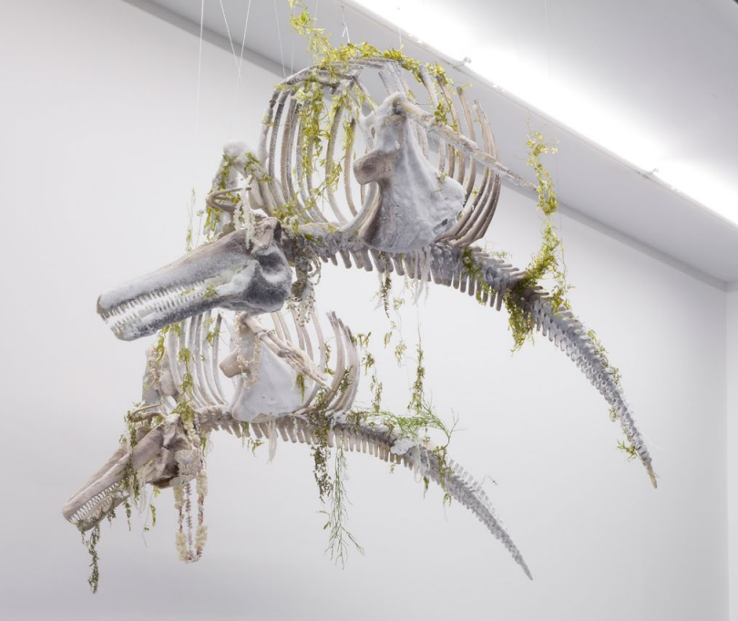
Bianca Bondi, Red List Hector's Dolphin (The Fall and Rise) (2021), Dolphin skeleton in resin and fiberglass, dried plants, and a beaded necklace crystallised in salt.

A HIGHLIGHT OF THE CALDER YEAR
The inaugural weekend of 16, 17 and 18 October 2026 will be one of the major moments of the regional cultural season.
It will bring together representatives of the Centre Pompidou, elected officials and teams from the Centre-Val de Loire Region, members of the Calder family, collectors, museum directors, artists, journalists and economic stakeholders from across the region.
Beyond the exhibition itself, this gathering aims to affirm Touraine’s place as a region of cultural creation and experimentation.

ABOUT THE MARGAUX AND RAPHAËL BLAVY COLLECTION
For a decade, the Margaux and Raphaël Blavy Collection has brought together major works from contemporary African and diasporic art scenes.
Beyond collecting, it pursues a committed curatorial approach based on supporting artists, producing original projects and creating dialogues between heritage, place and contemporary creation.
Through its exhibitions, publications, loans and institutional collaborations, the collection actively contributes to the recognition of contemporary African artists on the international stage.

MONUMENT’AFRICA IN NUMBERS
20 international artists
4 heritage sites
1 village engaged
1 partnership with the Centre Pompidou
50 years since Alexander Calder’s death
Several monumental installations and site-specific commissions

CONCLUSION
Through MONUMENT’AFRICA, the Margaux and Raphaël Blavy Collection proposes far more than an exhibition.
It experiments with a new way of shaping place through art.
At a time when many institutions are seeking to renew their relationships with audiences, places and landscapes, MONUMENT’AFRICA advances a simple proposition:
contemporary art should not merely occupy a territory.
It can help reveal it.
Between Calder’s legacy, Touraine’s rich heritage and the energy of contemporary African art scenes, MONUMENT’AFRICA sketches the outlines of a new cultural model in which heritage and creation no longer regard one another from a distance, but together build a shared experience.
The exhibition is only the beginning.

PRACTICAL INFORMATION
Château de Montgoger, 37800 Saint-Épain, France.
Press visits: 26–27 September 2026.
Inaugural weekend: 16–18 October 2026.
Open to the public: 16–18 and 23–25 October 2026, then 30 October–2 November 2026.
Partners: Centre Pompidou, Centre-Val de Loire Region, AR(T]CHIPEL Festival.
MONUMENT’AFRICA: The Calder Year Meets Contemporary African Art
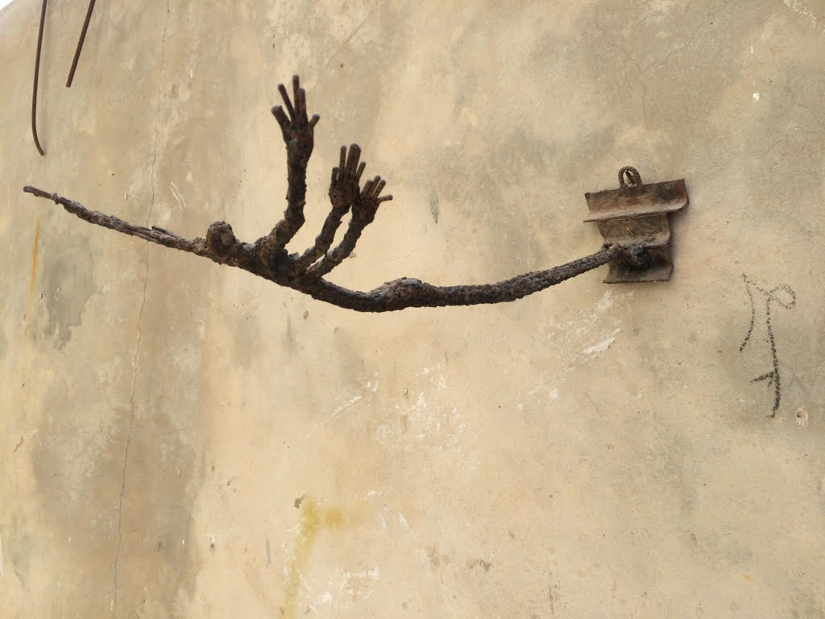
Ndary Lo, Triple Flight (2010), Welded reinforcing steel

